# A chapter entitled “The F1.5 layer”

## Context – guidance for authors.

This chapter is intended to form part of a supplement to UAG-23 / UAG-23A to provide rules and guidance on the interpretation of individual ionograms containing a F1.5 layer.

Before reading this chapter we expect any reader to be familiar with at least chapters 0 to 3 of UAG-23A. Hence there is no need to repeat any of that information in this chapter. Rather we are focusing on adding a chapter that covers one discrete phenomenon.

The goal is to present a Final Proposed Draft text[1] to the 2026 GASS[2] meeting.

## 0.2 Contributors

As soon as you make a contribution add your name to the table below. Please don’t be shy or humble as we want to credit everyone who contributes to this chapter. Please add your affiliation – no matter how long or short it might be. Please add the country in which you are working to give a flavour of just how wide spread the contributions have been.

| Name | Affiliation | Country |
| --- | --- | --- |
| Dr Samuel Ritchie | Commission for Communications Regulation | Ireland |
|  |  |  |
|  |  |  |
|  |  |  |
|  |  |  |
|  |  |  |
|  |  |  |
|  |  |  |
|  |  |  |
|  |  |  |
|  |  |  |

## How this process will work

I am co-ordinating this work and the work only progresses as I receive contributions.

This is the master document which will become the chapter dealing with the F1.5 layer.

I will make the latest master available for download from my website[3]. Feel free to take a copy from there to work on. If you are going to add text make sure to download the latest version to work on.

Add what you can and email the document back to me[4] . It does not matter how much or how little you have done. You can always download the latest master when you are ready to contribute some more.

Revision marks should not be turned off – I need to see what you have done by following the revision marks in order to update the master document.

Please send me high definition graphics of any ionograms you insert which I will store – this is in case we go for a high quality printing, or if I am annotating graphics.

No doubt we will need to explain things by annotating graphics, i.e. mark up the ionogram. I would prefer to make all those annotations myself so that all the annotations in the chapter use the same colour, style, font, size, etc. As long as you have sent me the high definition graphic you could just write the annotations on a copy, scan it and email it to me.

Do not forget to add full references if you reference anything – just write them into the body of the text and I will sort them out when we approach the end.

I will regularly update the master on my website and we repeat the process until we have a stable version.

A stable version has the following characteristics:

* Contributions of new material has dried up;
* Comments[5] on other people’s work have stopped; and
* It is clear why some headings are not required.

In that stable version I do not expect that we will agree on everything so there maybe be two or more different text options on a number of issues or on some examples. But, once we have a stable version we can have a ZOOM call to agree/compromise on matters or we hopefully will have the option to come to Dublin for a face-to-face meeting to finalise the document before we send it up for consideration.

I may have put in headings below that are simply not required[6] and I will delete the unwanted when we have a stable document.

## 0.4 Work to be done

The chapter starts on the next page.

The text in blue defines what needs to be drafted/found/inserted by contributors/authors.

The text in black is my comments, guidance, examples.

Revision marks are always on – this will help me keep the master document updated when many different contributions arrive.

# The F1.5 layer

**Discussion {to be deleted once document is stable}**

Heisler (1962) put forward that “*Certain peaks appearing on ionograms are interpreted as the result of a stratification between F1 and F2 and often designated F1·5. Frequent sampling shows that the cusps on the ordinary and extraordinary traces appear separated in time, which suggests that F1·5 is not a true layer stratification but is the result of distortion of the region due to a travelling disturbance. The similarity in the seasonal variation of the two phenomena supports this. Appearance of F1·5 on eclipse records may also be due to horizontal gradients of ionization rather than a true stratification. It is shown that ƒoF1 is probably often confused with ƒoF1·5 and that similar ambiguities may occur when anomalous peaks are introduced into ionograms by travelling disturbances in F2-region.”* In that same paper Heisler recommends procedures for interpreting ionograms when additional stratifications are evident in the F-region. These rules did not make provision for the recording of a F1.5 layer.

# Lynn, Harris and Sjarifudin (2000) refer to the stratification of the F2 layer as the F1.5/F3 phenomenon for want of a better description. The determination of whether a temporary layer is designated as F1.5 or F3 is decided by whether it forms and decays at a lesser or greater group-range than the F2 nose frequency. In other words, with reference to the layer which maintains continuity between the predawn F2 nose frequency and the post F1.5/F3, F2 nose frequency. Either phenomenon can occur and the designation cannot be made except by following the ionogram time series from before the occurrence of the F1.5/F3 until the phenomenon ends. The authors note that occasionally, the nose frequencies merge as the F layer expands and sinks in a manner which defies classification and in their experience find that it is often easier to recognize the distinction between an F1 5 and an F3 layer on an oblique ionogram than on a vertical one.

Lynn, Sjarifudin and Harris (2002) note that recent theoretical work has established an explanation for the stratification of the F2 layer, occurring in daytime, usually at sites displaced from the magnetic equator, but within the region covered by the equatorial anomaly. It is noted in that paper that the nomenclature use to describe F2 stratification has proved to be a problem and the history of naming additional stratification layers is given. In the case of a kink in the F2 profile (which could rise above the peak of the background F2 layer or

remain below the peak depending on the latitude of observation), the additional layer was referred to as an F3 or an F1.5 depending on whether the transitory layer moved above or stayed below the layer which maintained continuity with the pre- and post-stratification F2 layer.

Furthermore, the authors note that the F1.5 nomenclature suffers from the disadvantage of suggesting that this layer is below the F2 and possibly associated with the F1. However, observations clearly show that the base of the F2 layer maintained continuity throughout the period of stratification and that all layers produced by the stratification appear to exist as a distortion of a normal F2 layer. Therefore there may be value in the nomenclature to be used that would associate them with the F2 layer in some way. Some possibilities include F2-, F2, F3 or F2-, F2 , F2+ or F21, F22, F23 etc. Occasionally even these descriptions will require modification at times (usually brief) when the F2 has two kinks in the profile giving rise to 3-4 apparent layers in the F2. Finally the authors conclude that “*if a straight forward counting nomenclature is used, then it may also be helpful to try and identify the layer peak, which reverts to the F2 peak post-stratification. In any case, some consistent means of identification would be helpful in attempting to scale stratified ionograms”.*

A comment from Samuel on what we are trying to achieve: We are not scaling ionograms as an end to itself. We are scaling ionograms to support scientific endeavour. Our scaling rules must help answer questions such as:

* how often does the F1.5 layer occur;
* when does the F1.5 layer occur;
* what is the critical frequency of the layer;
* how does the altitude vary when it occurs;
* does it exceed the normal foF1 or normal foF2;

Compared to the F2 layer the F1.5 layer is a sporadic layer and should be treated as such. While it may be required to look at a time series to make the identification, when a F1.5 layer has been identified then the single ionogram needs to be scaled according to these rules. The life of a F1.5 layer can be determined from the scaling of a sequence of individual ionograms – using these rules the scaler could even develop an F plot that includes the F1.5.

However this is not possible if we:

* change the name of the layer to F3 the moment it moves above the normal F2 layer; or
* Swap foF2 for foF1.5 the moment the F1.5 layer moves above the normal F2 layer.

Local scalers will know the ranges in which the normal F1 and F2 layers occur. They can see from the time series what is happening and can follow the F1.5 layer even if it moves higher than the normal F2 layer.

A comment from Samuel on nomenclature: I understand the point made that what we are seeing is a distortion of the normal F2 layer, but it appears to be accepted that speaking of an F1.5 layer refers to a stratification that occurs between the normal F1 and F2 layers. I do not see the value in trying to change the nomenclature to F2-, F22, etc.

A comment from Samuel on type(s): We can capture the fact that that the F1.5 layer is higher than the F2 layer by designating a type – e.g. Type Ͷ denotes a F1.5 Layer that is sitting at a virtual height above the normal F2 layer.

## General Description.

Insert a real-life example of a real ionogram showing a well-defined F1.5 layer.

Provide a general description if what the example ionogram is showing.

Talk, in a general manner, about the occurrence of the F1.5 layer at low, mid and high latitudes.

At low-latitudes the F1.5 layer is …….

At mid-latitudes the F1.5 layer is often …….

However at high-latitudes the F1.5 Layer has never been identified as occurring.

The F1.5 layer is a sporadic layer and is studied on a local and regional basis.

Figure 1 is a real example of an ionogram showing a F1.5 layer. To demonstrate that observation of a time series may be required to make a clear identification, Figure 2 shows the time series from which Figure 1 was selected.

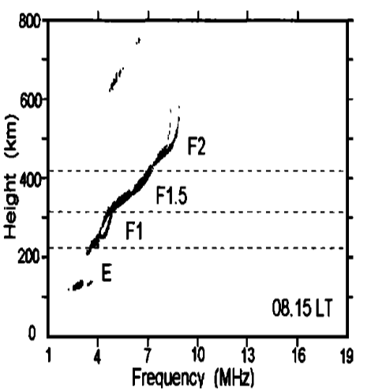

Figure 1. Vertical ionogram from the Vanimo ionosonde showing an F1.5 layer on 7 November 1997 at 08:15LT. From Lynn, Harris and Sjarifudin (2000)

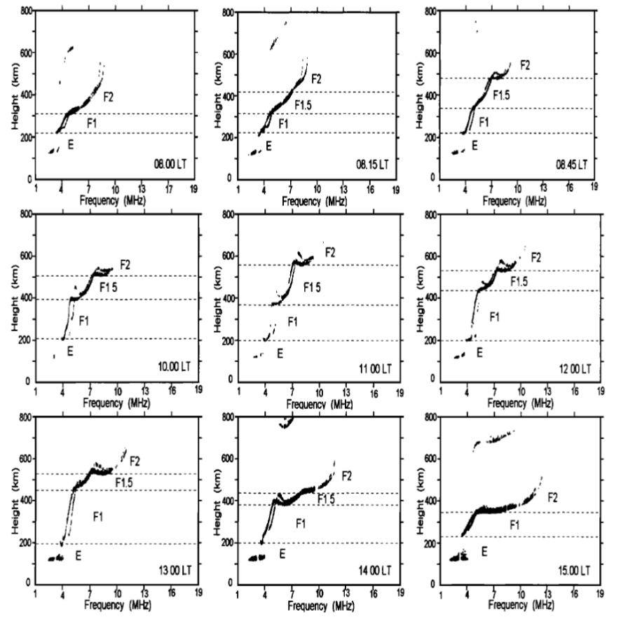

Figure 2 Time series of vertical ionograms showing the development and decay of an F1.5 layer at Vanimo on November 7. 1997. From Lynn, Harris and Sjarifudin (2000)

## Definition.

An F1.5 layer is an intermediate stratification between the F1 layer and the F2 layer that is often observed at certain middle and low latitude stations, used for local or regional studies.

See the guidelines to deal with instances where the F1.5 layer moves to an altitude exceeding that of the F2 layer for a period.

## Proposed parameters.

Here we need to detail the parameters that we want to scale to make use of the data provided by ionosondes.

As detailed in 0.23 (page 3 of UAG-23A) we can propose parameters based on:

* Parameters required for worldwide studies – we can have one example ionogram showing these.
* Parameters required for regional studies (different latitudes) - we can have one example ionogram showing these for one region.
* Parameters required for local studies - we can have one example ionogram showing these for a specific location.

There are two parameters that are of scientific value that should be scaled.

foF1.5: The ordinary wave critical frequency of the intermediate stratification between the F1 and F2 layers.

hʹF1.5: The minimum virtual height of the ordinary wave trace F1.5 layer.

## Guidance notes for scaling

Notes to guide those doing the hard work of scaling.

Include a note on how we have retained backward compatibility (if necessary).

To fall within the definition requires the ionogram that is to be scaled, to clearly show both an F1 and F2 layer. Without these two layers it is not clear how an F1.5 layer can be accurately identified or followed through a series of ionograms.

Therefore, it is assumed that the scaler has a view on the normal height of the F1 and F2 layers. This will assist in identifying the F1.5 layer in the case were the F1.5 layer rises above the F2 layer.

Noting that the F1.5 layer is sporadic and in order to facilitate the study of the F1.5 layer it has been decided to maintain the nomenclature of F1.5 even if the virtual height of the F1.5 layer exceeds the virtual height of the normal F2 layer for a period.

## Types.

If there are different types of F1.5 layer then we need to present an example of each type, provide comment on the type and assign a lower case letter to each type. The exemplar is paragraph 4.83 (page 125 of UAG-23A).

Type Ͷ: Where hʹF1.5 > hʹF2 this is designated as type Ͷ.

Needs a scaled example here.

## Proposed scaling rules for each parameter

As exampled in paragraph 3.32 (page 102 of UAG-23A), here we want to propose the rules applicable to scaling the F1.5 layer.

For foF1.5 measure the highest observed frequency of the traces directly reflected from the F1.5 layer.

The normal descriptive letter symbols should be used to show the reasons for absent entries.

## Proposed scaling accuracy for each parameter

foF1.5 should be scaled with an accuracy of 0.1 MHz. Therefore the last digit of the scaled value is always in the range 0 – 9.

h’F1.5 should be scaled to the nearest 5 km.

## Proposed use of qualifying and descriptive letters.

Example text:

foF1.5 is indicted by a numerical value in units of 0.1 MHz with or without letters or by a letter only.

If we need to use qualifying and descriptive letters then we must ensure we align with the current list of qualifying and descriptive letters. These are found in section 2.3 (pages 34 -35) and a detailed explanation is in section 2 (pages 65 – 98) of UAG-23A).

We can have real life examples of the use of qualifying and descriptive letters in the next section.

## Examples of scaling the F1.5 layer.

We can present as many real-life examples of scaling ionograms, in colour, as we deem necessary to give the reader a good handle on scaling F1.5 layers.

We can have simple to complex.

We can have examples from all latitudes.

We can demonstrate the use of all the descriptive and qualitative letters.

We can have special cases if there are any.

For each example the framework to use when describing the example is[7]:

Observation:

The trace below 3.2 MHz fades away due to the high absorption present as evidenced by fmin.

Interpretation:

Frequencies below fmin are affected by absorption. Therefore, the numerical value should be accompanied by the qualifying letter E and the descriptive letter B.

Comment:

Absorption of this magnitude is rarely observed between 01:00 and 04:00 local time at all low-latitude ionosondes.

## References.

We can add citations to papers that deal with the F1.5 layer here. BUT… they be useful for interpreting ionograms, this is not be a history lesson, a survey of everything we know, etc.

Heisler (1962): L.H. Heisler, The anomalous ionospheric stratification F1·5, Journal of Atmospheric and Terrestrial Physics, Volume 24, Issue 6, 1962,

Pages 483-489, ISSN 0021-9169, <https://doi.org/10.1016/0021-9169(62)90212-X>.

Lynn, Sjarifudin and Harris (2002): K.J.W. Lynn, M. Sjarifudin and T.J. Harris; F1.5/F3 layers in the Equatorial ionopsphere, INAG bulletin number 63, https://www.ursi.org/files/CommissionWebsites/INAG/web-63/index.html

Lynn, Harris and Sjarifudin (2000):K.J.W. Lynn, T.J. Harris and M. Sjarifudin; Stratification of the F 2 layer observed in Southeast Asia, Journal of Geophysical Research, Vol. 105, No. A12, pgs 27,147-27,156, December 2000, <https://agupubs.onlinelibrary.wiley.com/doi/epdf/10.1029/2000JA900056>

Ends …./

1. This is ITU terminology for a document that is ready for approval by a plenipotentiary meeting – which for URSI is GASS.
2. Scheduled for 15 – 22 August in Krakow, Poland.
3. [www.samuelritchie.com/ionogram](http://www.samuelritchie.com/ionogram)
4. Use [samuel.ritchie@comreg.ie](mailto:samuel.ritchie@comreg.ie)
5. Always polite comments of course.
6. Which we recognise as there have been no contributions made under these headings.
7. Text below is completely made-up.