|  |
| --- |
| Update of Chapter 4 of UAG-23A |
| Es characteristics |

Version of 06 September 2024

Contents

Section Page

4 Es Characteristics 6

4.0 General Considerations 6

4.1 Es Characteristics to be tabulated 9

4.2 Es Scaling conventions 10

4.3 Techniques for distinguishing between the magneto-electric components in Es traces. 14

4.4 Scaling of foEs 27

4.5 Scaling of fxEs 29

4.6 Scaling of fbEs 31

4.7 Scaling of h ʹ Es 36

4.8 Classification of “Types of Es” 37

4.9 Provisional f plot indication of fxEs 51

4.10 Examples of scaling low-latitude Es (new heading) 51

4.11 Examples of scaling mid-latitude Es (new heading) 51

4.12 Examples of scaling high-latitude Es (new heading) 51

4.13 References (new heading) 52

Annex 1: Holding space for Annex 53

Tables

Section Page

Table 4.1 Distinguishing Es components 26

Table 4.2 Summary of the use of J, 0, M and X for foEs or fxEs 30

Figures

Section Page

Figure 4. *1 There is no caption in the original* 7

Figure 4. 2: Conventions for Es type and Particle E 11

Figure 4. 3: No Es present. Use of G. 13

Figure 4. 4: FtEs below fB at night, ftEs is foEs. 16

Figure 4. 5: ftEs above Fb at night. 16

Figure 4. 6: foEs at night 19

Figure 4. 7: ftEs>fminFx 19

Figure 4. 8: ftEs = fminFx 20

Figure 4. 9: fminx given by fminFx Daytime 20

Figure 4. 10: fminx given by fminEx 21

Figure 4. 11: ftEs determined by fminEx 21

Figure 4. 12: ftEs determined by fminEx 22

Figure 4. 13: Total blanketing. Normal absorption 22

Figure 4. 14: Superposed components 23

Figure 4. 15: Scatter present 23

Figure 4. 16: foEs near expected value of foE 24

Figure 4. 17: fminFx not visible, absorption normal 24

Figure 4. 18: fminFx not visible, absorption large 25

Figure 4. 19: Scaling of fbEs 31

Figure 4. 20: Non-blanketing Es 32

Figure 4. 21: Blanketing indicated by strong second order Es {4.21} 33

Figure 4. 22: Trace missing due to a severely tilted layer 34

Figure 4. 23: Es type f, flat 40

Figure 4. 24: (a) (b) Es type l low 41

Figure 4. 26: Es type h, high 43

Figure 4. 27: Es type q, equatorial 44

Figure 4. 28:Es type r, retardation 44

Figure 4. 30: Es types, slant 46

Figure 4. 31: Es types. Partial reflection from absorbing layer 47

Figure 4. 32: Rules for interpreting foEs and fbEs in daytime. 47

Figure 4. 33: Rules for interpreting foEs and fbEs at night. 48

2. Es Characteristics
   1. General Considerations
   2. The scaling conventions for the Es parameters to be circulated on a world-wide basis are based on a compromise. It is clear that a wide variety of phenomena are included under the name sporadic E, and the study of these phenomena is not yet sufficiently developed to permit them to be considered separately on a world-wide basis [A40I, Figs. 31, 33, 34; A88I, Figs, 64, 77-79; A96I, Figs. 87-91, 93-99; A112I, Figs. 130, 131, 141, 142]. Diagrams illustrating Es have been given in Figs. 1.2, 1.8, 1.9, 1.11, 2.19, 3.1, 3.2, 3.3, 3.4, 3.5, 3.6. The distinction between types of Es facilitates the study of this problem (section 4.8). An additional difficulty arises because a given type of trace may arise from different causes, particularly in widely spaced parts of the world. It is always tempting to regard the current local interpretation as general and to simplify the rules accordingly. This is advantageous for local studies but can cause serious discontinuities in the compatibility of data from different regions or epochs.
   3. The basic rule is that all traces from E region height except normal E (and E2), should be treated as sporadic E traces.
   4. The distinction between blanketing and non-blanketing traces is very important both scientifically and operationally, and tabulations of the blanketing frequency fbEs can be at least as useful as those for foEs. It should be noted that fbEs is determined at a well-defined place where the ray path of the first higher echo goes through the Es layer. In contrast, foEs corresponds to the highest ordinary-wave frequency returned from Es in the sounding cone (which usually has an aperture of about± 10°) by a reflection or scattering mechanism. In most cases at high latitudes the Es traces found during disturbed conditions are blanketing when overhead and non-blanketing when seen at oblique incidence. Both parameters are highly variable in time so that it is particularly important that the number of values which contribute to the medians should be kept as large as possible.
   5. The Es characteristics to be scaled (Fig. 4.1) fall into two groups: (1) numerical measurements, e.g. foEs, fbEs, h'Es, which must be made sufficiently homogeneous to be useful for geophysical studies and the prediction of radio frequency propagation phenomena; and (2) type indices showing the incidence of different types of Es traces with time and position on the world.

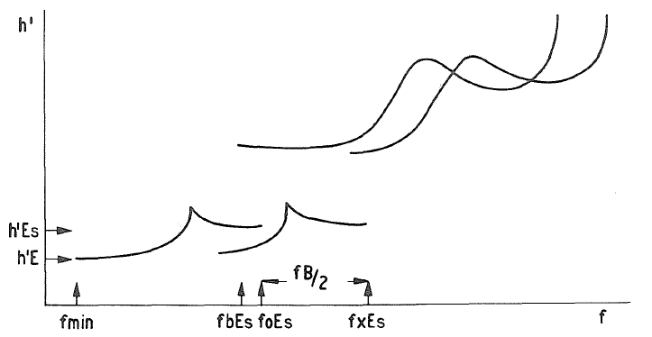

Figure 4. *1 There is no caption in the original*

* 1. In the use of data foEs has considerable advantages over fxEs and the provision of homogeneous tables of either parameter is more valuable than a table containing a mixture of both, even when individual values are clearly marked as due to o or x components. The international standard parameters are, therefore, based on the ordinary-wave component though departures from this convention are permitted where really necessary. The rules given for identifying the ordinary-wave component can, of course, be used to identify the extraordinary-wave component also. It is always implied that values tabulated as foEs have been obtained using the standard rules given below. Rules are also given to enable fxEs to be scaled if this is found to be desirable (see section 4.5).
  2. At stations where the advantage of scaling fxEs rather than foEs is great, tables of fxEs may be substituted for those of foEs. For practical reasons the blanketing frequency fbEs and the virtual height h'Es must always refer to the ordinary-wave component. The following rules have been arranged using the assumption that the characteristics scaled are foEs, fbEs and h'Es. They apply with appropriate changes (indicated in section 4.5) if fxEs, fbEs and h'Es are the characteristics scaled. The selection rules for foEs and fxEs are summarized in a table in section 4.32.
  3. Where the data from a station are processed mechanically it is not essential to make the original reductions homogeneous, provided the different components are clearly identified by one or other of the descriptive letters O and X, or, in really doubtful cases, M. The process of addinq or subtracting fB/2 can be done mechanically so as to produce homogeneous tabulations for interchange. This relaxation of the rules is allowed only when the operator knows that the corrections will be made by computer and that he has taken precautions to use symbols O, X, M accurately.
  4. Storm types of Es trace (Es types a and r) often change into the trace of a thick E layer, particle E or vice versa. foEs and fbEs then become equal to the critical frequency of the particle E (foE)-K. As discussed in detail in section 4.2 the characteristics foEs and fbEs are shown in both Es and E tables when particle E determines foEs.
  5. Not used
  6. Not used
  7. Not used
  8. Es Characteristics to be tabulated
  9. The following characteristics are normally tabulated for Es:

foEs: The ordinary-wave top frequency corresponding to the highest frequency at which a mainly continuous Es trace is observed.

h'Es: The lowest virtual height of the trace used to give foEs.

fbEs: The blanketing frequency of an Es layer, i.e., the lowest ordinary-wave frequency at which the Es layer begins to become transparent. This is usually determined from the minimum frequency at which ordinary-wave reflections of the first order are observed from a layer at greater heights.

Note: foEs, fbEs and h'Es must all be scaled using the same Es trace.

A numerical value for foEs, fbEs and h'Es (with qualifying and descriptive letters, where appropriate) or a descriptive letter replacing a value, is entered on the daily tabulation sheet for all of the 24 hours.

* 1. Es types: There are eleven specified categories into which Es traces are classified (section 4.8). The number seen at one station is usually smaller.
  2. Units for tabulation:

foEs and fbEs: 0.1 MHz

h'Es:

1. with expanded height scale ionograms, 1 km;
2. when scaling accuracy is better than ±2 km tabulate to nearest odd km at least;
3. when scaling accuracy is better than ±5 km tabulate to nearest 5 km.
   1. not used
   2. not used
   3. not used
   4. not used
   5. not used
   6. not used
   7. not used
   8. Es Scaling conventions
   9. Since the values of foEs and fbEs observed can change with the sensitivity of the ionosonde, these parameters should be deduced using the ionogram obtained at normal (medium) gain.
   10. h'Es should be scaled using the ionogram on which it can be measured most accurately.
   11. Traces due to thick occulting layers, such as 'E2' or other 'intermediate layers' in the day should not be included in Es tabulations (this does not apply to particle- E), (see below).
   12. Rules when particle E is present: When foE at night is greater than the value appropriate for normal E (K condition, section 3.2), particle E is present. This is usually preceded by Es type r. The critical frequency of particle E is usually much greater than for normal E at this time. Typical stages in the development from retardation Es (type r) to particle E are shown in Fig. 4.2. Occasionally the sequence of Fig. 4.2 is found with Es type a traces instead of Es type r traces. In particular, the F traces show the same sequence, and with the same interpretation. (See High Latitude Supplement).

Case (i) No retardation at low frequency end of F trace, Fig. 4.2(a), Es type r; h'Es, foEs, fbEs as shown.

If foE below fmin, foE is (fmin)EB, h'E is B[1]

If foE above fmin, foE is (fbEs)EA, h'E given by E trace (very uncommon except on low frequency ionograms).

Case (ii) Retardation at low frequency end of F traces, Fig. 4.2(b), Es type r, foEs as shown.

fbEs is (foE)UK h'Es is xxx

foE is (foE)UK h'E is A

(There is always some doubt when only half a cusp is visible; hence, U preferable. Also E layer could be above Es-r.)

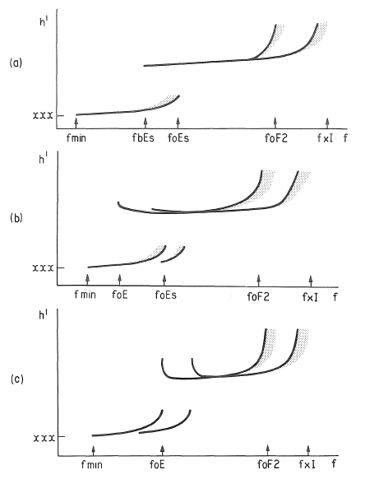

Figure 4. 2: Conventions for Es type and Particle E

(a) (b) show Es type e (c) particle E

In (b) foE for night can be seen by retardation of F trace; (foE)UK but hʹE is A

In (c) foEs and fbEs = (foE) – K hʹE =( hʹE) - K

Case (iii) Particle E, Fig. 4.2(c).

Es type k (particle E)

foEs is ( foE) – K h'Es is (h'E) - K

fbEs is (foE) – K

foE is (foE) – K h'E is xxx - K

Note, unless fmin is high, both o and x traces will normally be seen when particle E is present.

Whenever fbEs is given by a particle E trace, fbEs = (foE)-K. The entry (foE)-K must be put in both the foE and the appropriate Es tables (foEs and fbEs).

Case (iv). Particle E with another Es type present (example not shown).

Es types h, c, l, and a occasionally occur superposed on a particle E trace. In these cases foEs, fbEs, h'Es are given by the trace with the highest critical frequency. The presence of particle E is shown in the normal E tables under foE, h'E with descriptive letter K and in the Es types table. When the Es type is not blanketing the normal G rule applies, fbEs = (foE)EG.

* 1. When no Es echoes are observed the following conventions are adopted:

If a trace corresponding to a thick layer in the E region, e.g., normal E, or retardation is present at the low frequency end of the ordinary-wave F-region trace, the descriptive letter G must be used; appropriate rules are found in section 3.2 (G), (Fig. 4.3).

If fmin is greater than the lower limit of the ionosonde and absorption is clearly indicated, foEs = fbEs = (fmin)EB and h'Es = B, except when letter G applies.

In all other cases the descriptive letter used for fmin should also be used to describe the absence of the Es trace (e.g., C, E, S).

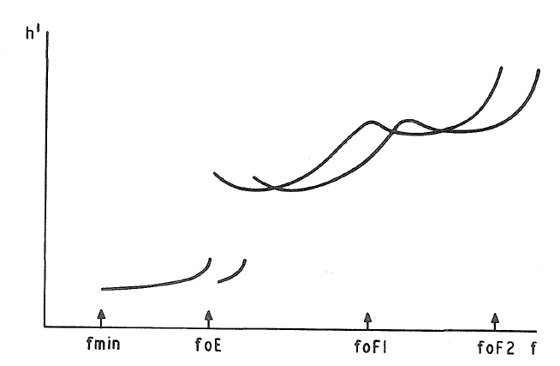

Figure 4. 3: No Es present. Use of G.

foEs is (foE)EG

fbEs is (foE)EG

hʹEs is replaced by G

* 1. Not used
  2. Not used
  3. Not used
  4. Not used
  5. Techniques for distinguishing between the magneto-electric components in Es traces.
  6. The evaluation of foEs depends on distinguishing whether the top frequency, ftEs, observed is due to an ordinary, foEs, or extraordinary, fxEs, wave reflection. There are a large number of possible cases which are discussed in detail in section 4.31, paragraphs (a) to (g) and summarized in section 4.32. These enable any difficult case to be evaluated. For most ionograms there is little difficulty since there are ample indications (e.g., 4.3l (a), (b)) of whether ftEs is fxEs or foEs. In most practical cases it is fxEs. The simplest criterion is to see if F region x traces are present at or below ftEs; if so, it is fxEs, if not foEs. When absorption is not present, e.g., at night for most latitudes, ftEs equals fxEs if it is more than about 250 kHz above the gyro-frequency fB and foEs if it is below this frequency. Near fB it is foEs. Borderline cases should show easily recognized, separate o and x traces. During daytime hours, observe the relation between the minimum frequency of the x traces, the number of multiple traces present and their minimum frequencies. Usually absorption conditions are similar from day to day and hour to hour so that if ftEs is seen at a frequency where x traces are usually seen it will be fxEs. Always try to use several tests in doubtful cases, and refer to the paragraphs below to make sure the correct interpretation has been made. As fmin increases due to absorption, the lower frequency part of the x trace disappears and it becomes more likely that ftEs equals foEs. Always check that no F-layer x trace is visible at or below ftEs.

If the ionosonde is faulty, a logical approach may not be successful. Direct comparison of the difficult case with ionograms with identifiable Es traces, or with no Es and similar absorption, will usually show clearly whether ftEs is fxEs or foEs.

4.31. Detailed rules for distinguishing foEs:

1. For normal thick reflecting layers, differences in the virtual height of reflection of the two magneto-electronic components generally enable the two traces to be identified easily. The daytime 'c' and 'h' types of Es give traces which can often be identified by the changes in height of the trace due to retardation in the normal E layer (Fig. 4.1). However, for most types of Es trace the two components are superposed at essentially the same height and other criteria are necessary.
2. When absorption is present, a clear distinction is often possible because the absorption of the x component is normally greater than that of the o component at the same frequency. The x component is also greatly weakened at frequencies near the gyrofrequency, even when the normal absorption is very small.
3. At night, when the absorption is usually negligible, comparison of the top frequency of the Es trace, ftEs, and the gyrofrequency, fB, gives the following rules:

If ftEs < fB ftEs = foEs (Fig. 4.4)

If ftEs > fB ftEs = fxEs (Figs. 4.5 and 4.6)

1. Systematic inspection of the ionogram can very often determine which component is present at the high frequency end of the trace, even in cases where both traces are superposed and show no obvious distinguishing features. The first method depends, in essence, on comparing ftEs with the minimum frequency of the x-component trace for the ionogram as a whole, fminx. This is necessarily above the gyro-frequency. 1f Es traces occur at frequencies above fm1nx, the extraordinary component must be present. Hence the top frequency, ftEs, must correspond to the extraordinary component. If the Es trace stops at a frequency below fminx the extraordinary component cannot be present.

Thus if ftEs ≥ fminx ftEs = fxEs

And if ftEs < fminx ftEs = FoEs

The rule can only break down if there is a sudden change in the variation of the sensitivity of the ionosonde with frequency. This should not occur with properly maintained modern equipment, but is readily recognized when present. Clearly it is not necessary to measure fminx, it is sufficient to know that fminx is greater or smaller than ftEs.

Figure 4. 4: FtEs below fB at night, ftEs is foEs.

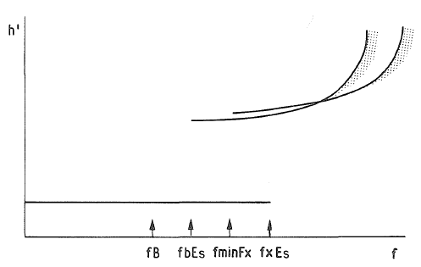

Figure 4. 5: ftEs above Fb at night.

ftEs above fminFx so ftEs is fxEs

Note fmin low so absorption small.

1. The high frequency end of the record should be inspected first. In most cases there is no difficulty in recognizing the two components in the F traces and the low frequency end of the F-layer x trace is easily found. This is called fminFx and provides a useful practical criterion. Three cases can arise in practice:
2. ftEs > fminFx (Fig. 4.7)

The Es trace must contain an x component and hence ftEs = fxEs.

1. ftEs = fminFx (Fig. 4.8)

When the difference δ between ftEs and fminFx is less than half the gyrofrequency, fB/2, the top frequency cannot be foEs without an x trace appearing at higher frequencies. Therefore ftEs = fxEs. This is shown by an indirect argument: Suppose the Es trace visible up to fminFx - δ is an ordinary trace (δ ≤ fB/2). Then the corresponding x trace should stop at (fminFx – δ + fB/2) and this is higher than fminFx. Thus this trace cannot be absorbed and should be visible on the ionogram. As this is not true in the case we consider, the hypothesis that we have an ordinary trace must be wrong, so that ftEs = fxEs.

1. ftEs < fminFx

Two subcases are possible:

1. No E-region trace (neither E nor Es) appears within half the gyrofrequency below fminFx (Fig. 4.9). This shows that, taking the ionogram as a whole, the x trace stops at fminFx so that fminFx = fminx. Hence the observed Es trace cannot be an x trace and ftEs = foEs.
2. An x trace from a thick layer in the E region is present (E or E2). In this case the arguments used above are repeated for fminEx instead of fminFx giving the three cases illustrated in Figs. 4.10, 4.11, 4.12.

These rules can fail if the equipment limitation mentioned in (d) above is present.

1. There remain the cases where fminFx cannot be determined. If this is due to total blanketing (Fig. 4.13), in conditions for which we would normally expect to see the F traces we should presume that the missing F-layer x trace is replaced by an Es-layer x trace and therefore ftEs = fxEs.

Sometimes, but rarely, ionograms are obtained which apparently differ from the cases dis­ cussed above. These differences are most commonly due to layer tilts causing oblique sounding reflections. For example see the discussion on fbEs (Fig. 4.22(a) (b)). The remaining case where fminFx cannot be determined although an Fx trace is, present is the only difficult one. This condition is found when both components are superposed (Fig. 4.14) or when scatter is present (Fig. 4.15). This is discussed in (g) below.

1. It is only necessary to attempt to identify the Es traces directly when the frequency rules cannot be applied. When no absorption is present rule (c) always applies. When absorption is present we may use our experience of the usual behaviour of the ionosphere, at most stations, to provide a basis for informed reasoning of the probable interpretation.

If ftEs is comparable with foE it is probable that the x component of the Es trace is absorbed and ftEs = foEs (Fig. 4.16). This class is extremely rare as almost all cases can be solved by normal rules.

If ftEs is considerably higher than foE, assume that the x trace is present and ftEs = fxEs (Fig. 4.17).

If absorption is present at night but no particle Eis visible the value of fmin may be used to estimate whether ftEs = foEs or ftEs = fxEs, high values of fmin suggesting the former. In particular if ftEs is near fmin, ftEs = foEs (Fig. 4.18).

Summarizing these considerations it can be stated that in almost every really doubtful case it may be assumed that ftEs = fxEs.

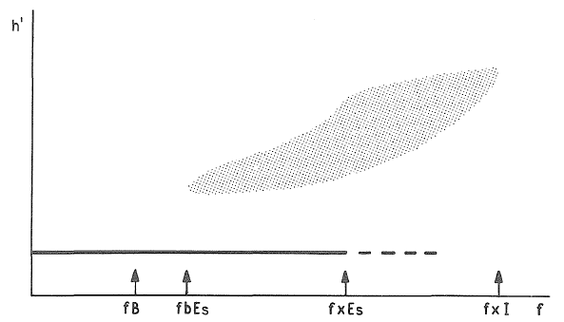

Figure 4. 6: foEs at night

Note fmin low so absorption small (---- weak trace).

Figure 4. 7: ftEs>fminFx

Figure 4. 8: ftEs = fminFx

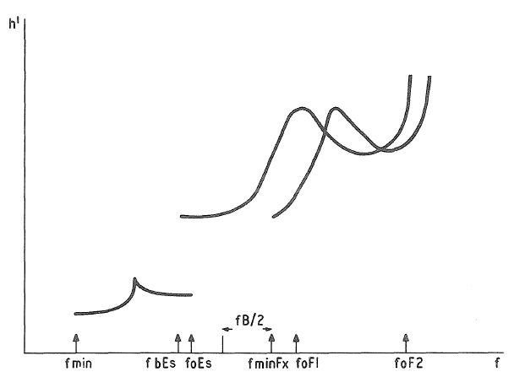

Figure 4. 9: fminx given by fminFx Daytime

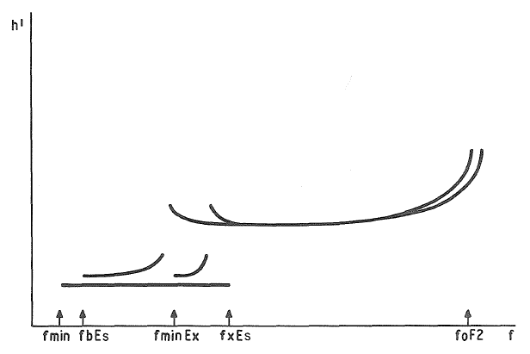

Figure 4. 10: fminx given by fminEx

foEs = (fxEs - fB/2)JA if foEs greater than foE

foEs = (fxEs - fB/2)JG if foEs less than foE

fbEs = (fbEs – G)

Es type low.

If E trace not horizontal h'E = (h'E)EA.

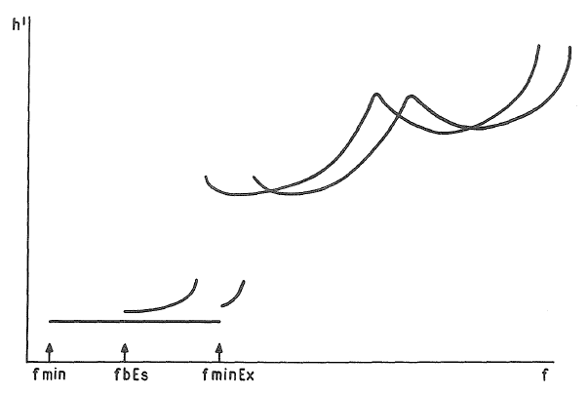

Figure 4. 11: ftEs determined by fminEx

ftEs is fxEs

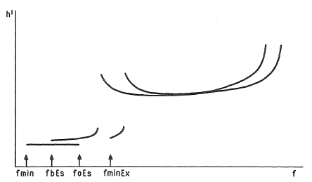

Figure 4. 12: ftEs determined by fminEx

ftEs is foEs

Figure 4. 13: Total blanketing. Normal absorption

ftEs is most likely to be fxEs

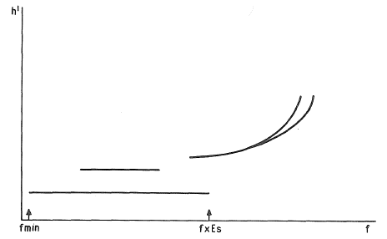

Figure 4. 14: Superposed components

ftEs is most likely to be fxEs in this case as absorption is small.

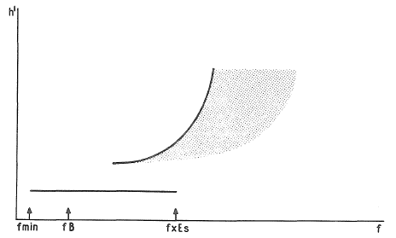

Figure 4. 15: Scatter present

If fmin normal, ftEs is likely to be fxEs.

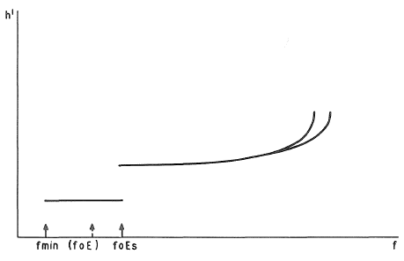

Figure 4. 16: foEs near expected value of foE

ftEs is most likely to be foEs (very rare case).

Figure 4. 17: fminFx not visible, absorption normal

Fmin normal

ftEs occurs at frequency where x trace would be expected to occur

foEs = (fxEs – fB/2)JA.

Figure 4. 18: fminFx not visible, absorption large

Fmin larger than normal, multiple reflections missing.

ftEs probably foEs as x trace usually much more absorbed than o trace.

* 1. Not used
  2. Instructions for distinguishing Es components.

|  |  |  |  |  |
| --- | --- | --- | --- | --- |
|  | Para. No. | Conclusion that  ftEs = fxEs | Conclusion that  ftEs = f0Es | Figure |
| General Rules | a, b | Separation by absorption or by group retardation. | | 4.1 |
| c | No absorption  ftEs > fb |  | 4.5  4.6 |
| c |  | No absorption  ftEs < fb | 4.4 |
| d | ftEs ≥ fminx | ftEs < fminx |  |
| When fminFx is known | e | ftEs > fminFx |  | 4.7 |
| e | ftEs = fminFx |  | 4.8 |
| e |  | ftEs < fminFx (no E trace present within fB/2 of fminFx | 4.9 |
| e | ftEs > fminEx |  | 4.10 |
| e | ftEs = fminEx |  | 4.11 |
| e |  | ftEs < fminEx | 4.12 |
| When fminFx is not known | 1. Estimate when absorption is absent | | | |
| f | Total blanketing |  | 4.13 |
| f | Superposed o and x traces |  | 4.14 |
| f | F layer scattered |  | 4.15 |
| 1. Estimate when absorption is absent | | | |
| g |  | ftEs ~ foE | 4.16 |
| g | ftEs >> foE |  | 4.17 |
| g |  | ftEs ~ fmin | 4.18 |
| g | At night ft >> fmin >> fB |  |  |

Table 4.1 Distinguishing Es components

* 1. Not used
  2. Not used
  3. Not used
  4. Not used
  5. Not used
  6. Not used
  7. Not used
  8. Not used
  9. Scaling of foEs
  10. The selection rules for identifying the Es trace which should be scaled are as follows:

1. Ignore all traces which indicate oblique reflections from evidence on the ionogram or the sequence of ionograms.
2. Ignore all very weak intermittent reflections, e.g., Fig. 4.6.
3. Ignore all rapidly varying or transient phenomena. For fast recorders, meteor traces which would otherwise resemble an Es trace can often be identified by the occurrence of fairly regularly spaced fading. These traces should be ignored.
4. Select from the remaining traces the one which is mainly continuous to the highest frequency. This trace should be used for scaling foEs, fbEs and h'Es. The highest frequency to which the trace is mainly continuous is called its top frequency. The current meaning of 'mainly continuous' is that a break in the trace which can be ascribed to an occasional fade or change in the sensitivity of the ionosonde is ignored if the trace continues regularly beyond the break. Rules (a), (c) do not apply to Es type a and r.
   1. The rules for measuring and tabulating foEs are:
5. When the ordinary and extraordinary Es traces are separated in virtual height or frequency (see section 4.3) or the ordinary component alone is present and identifiable, the top frequency of the ordinary-wave trace is the required value of foEs.
6. When the ordinary and extraordinary traces are not separated but evidence exists from the rules in section 4.31 (d tog; especially e, iii) that ftEs = foEs, this value is scaled as foEs.
7. When the rules for distinguishing between the components show that ftEs = fxEs, the pre­ ferred method is to subtract fB/2 from the observed value of ftEs and tabulate the re­ sultant value qualified by J and described by A
8. When the distinction between the components cannot be made but it is most likely that ftEs = fxEs, the preferred method is to subtract fB/2 from the observed value of ftEs and tabulate the resultant value qualified by J and described by M.
9. When the distinction between the components cannot be made but it is most likely that ftEs = foEs (an extremely rare case in practice), scale ftEs described by M.
10. When no Es trace is present on the ionogram the detailed rules given in section 3.2 for descriptive letters B, C, E, G and S are applied. The main points may be summarized as follows:

B - fmin is high; foEs equal to the numerical value of fmin qualified by E and de­ scribed by B.

C - Instrumental fault; foEs replaced by descriptive letter C.

E - fmin equal to lower frequency limit of ionogram; foEs replaced by descriptive letter E. (In determination of medians always use minimum frequency of ionosonde EE).

G - Normal E echo traces present. foEs replaced by descriptive letter G, preferably (foE)EG.

S - Night conditions; fmin tabulated with qualifying letter E and descriptive letter S. foEs tabulated in same way as fmin.

1. For stations with low frequency ionograms that have a wide interference band, see letter S in section 3.2 for use of letters DS with foEs.
   1. At stations where most values of foEs must be deduced from fxEs, it is permissible to omit the use of JA in rule (c) above. Es is too variable for the probable additional error to be significant unless the majority of values are direct observations of foEs. Rules (d), (e) should be ob­ served in this case.
   2. The international rules allow two simplifications to be made to the scaling rules (c), (d), (e) (section 4.42) at stations where conditions do not justify the work involved in calculating foEs. When the rules for distinguishing between the components show that ftEs = fxEs, tabulate ftEs with the descriptive letter X. When the distinction between the components cannot be made tabulate ftEs with the descriptive letter M. The use of these simplifications must be clearly indicated on foEs tables for interchange.
   3. Scaling of fxEs
   4. Tables of values of fxEs circulated in place of tables of foEs must always be clearly titled as follows:

fxEs ( foEs + appropriate mean value of the correction term fB/2).

* 1. The selection rules and instructions for distinguishing between the two components are identical to those for foEs:

1. When the ordinary and extraordinary Es traces are separated in virtual height or frequency (see section 4.42 (a), (b)) the top frequency of the extraordinary Es trace is the required value of fxEs.
2. When the ordinary and extraordinary Es traces are not separated but the identification rules show that ftEs = fxEs, the top frequency of the extraordinary Es trace is the required value of fxEs.
3. When the top frequency of the Es trace is known to be foEs, add fB/2 and tabulate the resultant value qualified by O and described by the letter showing why fxEs was not present, usually B, R or S.
4. When the distinction between the components cannot be made but it is most likely that ftEs = fxEs, tabulate the observed value of ftEs described by M.
5. When the distinction between the components cannot be made but it is most likely that ftEs = foEs (an extremely rare case in practice), add fB/2 and tabulate the resultant value qualified by O and described by M.
6. When no Es trace is present on the ionogram, the detailed rules given in section 3.2 for the descriptive letters B, C, E, G and S are applied (see also section 4.42).
7. For stations with low frequency ionograms that have a wide interference band, see letter S in section 3.2 for use of letters DS with fbEs.
   1. Not used
   2. Not used
   3. Not used
   4. Not used
   5. The use of J, 0, M and X for foEs or fxEs is summarized in the following table:

|  |  |  |  |  |  |  |  |  |  |  |  |  |
| --- | --- | --- | --- | --- | --- | --- | --- | --- | --- | --- | --- | --- |
|  | foEs | | | | | | | | fxEs | | | |
|  | Preferable | | | | Simplified | | | |
| Ordinary |  |  |  | |  | | | | xxx | 0 | B |  |
| Extraordinary | ooo | J | A |  | (ftEs) | - | M |  |  |  |  |  |
| Unknown, estimate o | . . . | - | M |  | (ftEs) | - | M |  | xxx | 0 | M |  |
| Unknown, estimate x | ooo | J | M |  | (ftEs) | - | M |  | … | - | M |  |
|  |  |  |  |  |  |  |  |  |  |  |  |  |
|  | | | | | | | | | | | | |
| *Numerical example:*  *(1/2 fB assumed to be 0.6)* | foEs | | | | | | | | fxEs | | | |
|  | Preferable | | | | Simplified | | | |
| Ordinary | 039 | - | - |  | 039 | - | - |  | 045 | 0 | B |  |
| Extraordinary | 067 | J | A |  | 073 | - | X |  | 073 | - | - |  |
| Unknown, estimate o | 041 | - | M |  | 041 | - | M |  | 047 | 0 | M |  |
| Unknown, estimate x | 089 | J | M |  | 095 | - | M |  | 095 | - | M |  |
| *Underlined values indicate that the numerical value has been directly obtained from the ionogram.* | | | | | | | | | | | | |

Table 4.2 Summary of the use of J, 0, M and X for foEs or fxEs

* 1. Scaling of fbEs
  2. fbEs is always determined using the ordinary-wave trace for the layer first seen through the Es.
  3. If several Es traces giving blanketing are present on the same ionogram, the value of fbEs to be tabulated is the value of blanketing frequency due to the trace which gave foEs (Fig. 4.19 (a) and (b)). All observed values of fbEs should be plotted on the f plot.

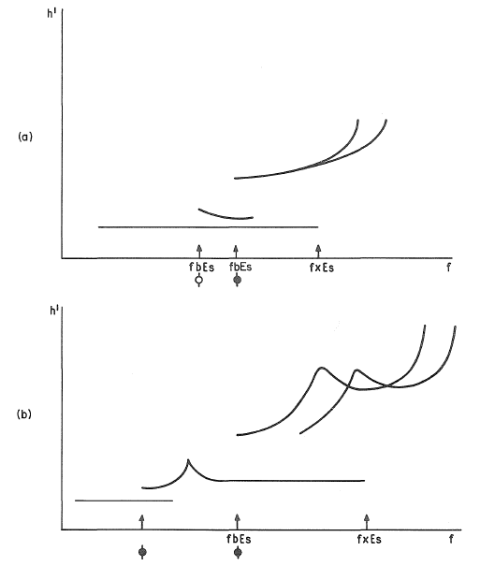

Figure 4. 19: Scaling of fbEs

The f plot symbols (Chapter 6) are also shown.

Note: (i) The tabulated value of fbEs is always given by trace with highest value of foEs.

(ii) All values of fbEs are shown on the f plot.

When the Es trace giving foEs is partially reflecting at all frequencies and a thick layer is present, fbEs is given by the critical frequency of the thick E layer trace associated with its lowest frequency qualified by E and described by G, Fig. 4.20.

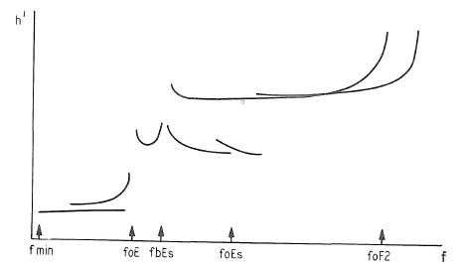

Figure 4. 20: Non-blanketing Es

This figure shows both Es type h and Es type l

foEs as shown

fbEs is tabulated as (fbEs)EG. (fbEs) is equal to foEs, the critical frequency of the intermediate 1ayer.

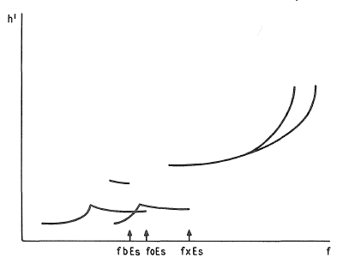

Figure 4. 21: Blanketing indicated by strong second order Es {4.21}

fbEs given by second order (fbEs)UY, see fig 4.22.

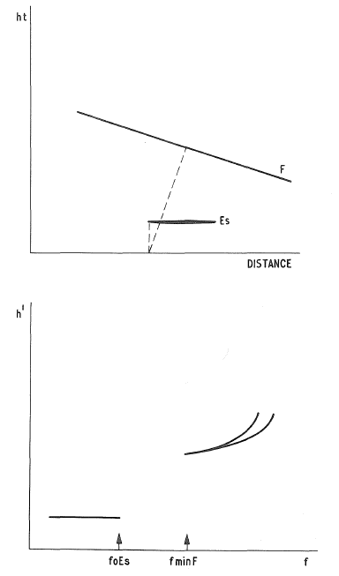

Figure 4. 22: Trace missing due to a severely tilted layer

fbEs = Y unless accuracy rules allow an estimated value to be made.

If in doubt use Y.

Note: The presence of the tilt will usually be detected by height differences between the first and second order F traces, (see section 2.7).

* 1. The value of fbEs cannot exceed foEs within the usual accuracy rules. When the minimum frequency reflected from higher layers is greater than foEs, fbEs can only be scaled if the ionogram (Fig. 4.21) or sequence of ionograms indicates that blanketing is present. The usual accuracy rules apply. Retardation at fminF indicates the presence of deviative absorption. If the multiple F-trace heights are consistent use R in preference to Y. A gap in frequency between the Es and F trace is most often produced by a tilt of the F-layer, which is then sounded in an oblique direction (Fig.4.22 (a) and (b)). The observed lower frequency limit of the F trace does not correspond to over­head conditions. The numerical value of foEs, qualified by U and described by Y, is tabulated for fbEs. This case can often be identified by comparing the first and second order F-region traces. A descriptive letter alone (e.g., S, C, R, Y) is used in these cases where blanketing is not clearly indicated.
  2. When Es is not observed the letter used to replace the numerical value of foEs is also used to replace that for fbEs (section 4.42).
  3. When complete blanketing occurs (i.e., no reflections from higher layers appear at all), it is not possible to evaluate fbEs with certainty. However, the statistics of fbEs lose much value if these high values are not numerical. Therefore, a new convention has been adopted as stated in section 3.2, letter A using fbEs = (foEs) AA unless this is clearly misleading.

1. If the trace is solid to foEs, tabulate (foEs)AA (Fig. 3.1).
2. If the trace is not solid to foEs, or if two or more multiple traces are present with the value of the top frequency of the second order trace much smaller than foEs (Fig. 3.2) tabulate the value of fbEs deduced from the top frequency of the second order trace with qualification AA respectively. (Note: If these values have to be deduced from the x-mode trace, AA should be used in preference to JA in cases (a) (b)). Values of fbEs deduced from the solid part of the trace and rule (a) should usually agree within the accuracy rules for limit values with the value deduced from ( b).
   1. The rules for interpreting foEs and fbEs have been summarized (R. Smith, INAG 10, p 5-6) for training purposes and are reproduced in Figures 4.32 and 4.33. The diagrams omit the x-mode traces and should be used as a guide only. Detailed rules are given in the text above.
   2. Scaling of h ʹ Es
   3. h'Es is the lowest virtual height of the trace used to give foEs. If the ionosonde is on gain runs, the height should be scaled from the ionogram on which it can be measured most accurately.
   4. When the low frequency end of the Es trace is affected by group retardation in a thick E layer and the Es trace does not become horizontal, tabulate the value of the lowest virtual height observed. The tabulated value is qualified by letter U or E as required by the accuracy rules, and described by the letter G.
   5. When Es is not observed, the letter used to replace the numerical value of foEs is used to re­ place that for h'Es also.
   6. Not used
   7. Not used
   8. Not used
   9. Not used
   10. Not used
   11. Not used
   12. Not used
   13. Not used
   14. Not used
   15. Not used
   16. Not used
   17. Not used
   18. Not used
   19. Not used
   20. Not used
   21. Not used
   22. Not used
   23. Not used
   24. Not used
   25. Not used
   26. Classification of “Types of Es”
   27. Classification procedures: Whenever possible all Es traces appearing on the ionogram should be listed in the column on the tabulation sheet provided for Es types. The classification is independent of the scaling rules for the characteristics foEs, h'Es and fbEs. Thus types of Es corre sponding to weak or oblique reflections can be recorded even though they are not scaled for numerical values. All observations available in the hourly sequence, including the high gain sounding, should be used in judging the types of Es present. [B section III pp. 1-10].
   28. Tabulation of Es types and multiple echoes: When more than one type of Es trace is present on the ionogram, the type for the trace used to determine foEs must be written first. The other Es traces are arranged in sequence of descending order of multiples except when Es-k is present. In this case Es-k takes precedence over all other Es traces except that giving foEs.

The first two types tabulated must each be followed by a number indicating the number of traces seen up to 9. If only the fundamental is present, however, number 1 must be tabulated. The number of reflections of a given type should be determined from the normal gain sounding.

* 1. Description of standard types: The nine standard types of Es are identified by lower case letters: f, l, c, h: q, r, a, s,_d. These letters suggest the corresponding names: flat, low, cusp, igh, equatorial, retardation, auroral, slant and D region, respectively. It is strongly emphasized that these names are not restrictive. The other two types are k and n where k denotes the presence of particle E and n is used to designate any Es type· which does not correspond to any other of the ten types [A94D].

The standard types are:

f: An Es trace which shows no appreciable increase of height with frequency, Fig. 4.23. Th trace s.usu lly relatively solid at most latitudes [A96I, Figs. 93 (b)(c)(e)J. This classification may only be used at hours when a thick E layer is not usually observable (the hours for which a numerical value of foE cannot be obtained). At other hours, apparently flat Es traces are classified according to their virtual height: h, c, or l [B III, 3, 9; IIA 59 Dec., 62 Dec., 63 June, 65 June, 70 June, 71 Raratonga June and Dec., 74 Dec., 82 June, 83 Dec.]. Low frequency ionograms show that most cases of night time f type Es would have been classified as l type though occasionally c or h type would be appropriate.

l : A flat Es trace at or below the normal E layer minimum virtual height or below the particle E layer minimum virtual height [A96I, Fig. 93(d)]. [B III, 3, 5, 9; IIB 36 Sept., 42 Dec.]. (Fig. 4.24 (a)(b)).

c: An Es trace showing a relatively symmetrical cusp at or below foE. This is usually continuous with the normal E trace, although when the deviative absorption is large, part or all of the cusp may be missing. (Usually a daytime type.) [A96I, Figs. 93 (d), 94, 95]. [B III, 4., 9. Many other cases]. (Fig. 4.25 (a)(b)).

h; An Es trace showing a discontinuity in height with the normal E-layer trace at or above foE. The cusp is not symmetrical, the height of the low frequency and of the Es trace being clearly higher than that of the high frequency end of the normal E trace. (Usually a daytime type.) [A96I, Fig. 97]. [B III, 4, 5; IIB 42 (all), 46 Sept. Freiburg, 51 S.ept., 52 Dec., 55 June, Sept., 57 Dec., 61 June, 62 June Tsumeb,64 June, 83 Dec.J. (Fig. 4.26 (a) (b)).

q: An Es trace which is diffuse and non-blanketing; commonly found during daytime in the vicinity of the magnetic dip equator. The lower edge is usually relatively well defined (Fig. 4.27). Often Es types can be superposed on this pattern, in particular Es- l can cause blanketing at the low frequency end. [A96I, Figs. 93(a), 98]. [B III, 8, IIB 84 Ibadan, Kunasi June; 85 Dec., 86 all; 87 all].

r: An Es trace showing an increase in virtual height at the high frequency end, similar to group retardation. The trace is blanketing over part or nearly all of its fre­ quency range. This is distinguished from the usual group retardation (as in the case of an occulting thick E layer) by the lack of group retardation in the F-lyer traces at foEs and the presence of an Flayer trace below foEs. [A96I, Figs. 93 to 96, Al04I, 120]. (see Figs. 4.2, 4.28).

a: All types of very diffuse (spread) traces are combined in auroral type Es. These can extend over severa1 hundred kilometres of virtual height. Typical patterns show a flat or slowly rising bottom edge to the pattern, with stratified traces in it which vary rapidly in time. The width of the trace is usually greatest well below foEs or fxEs, often at frequencies near fminF, Fig. 4.29. The pattern usually alters rapidly in time. Es-type a traces are due to oblique reflections and patterns at different virtual heights often varying independently (usually because they come from different directions). Multiple reflections are not seen until the reflecting structures move overhead, when the overhead traces usually correspond to Es type for Es type k are blanketing. Temperate latitude types Es h, c, l can be superposed on Es type a pattern though this is rare.

s: A diffuse Es trace which rises steadily with frequency and usually emerges from a normal E, particle E or Es trace [A96I, 93h, 98]. The rising trace alone is classified as "s"; the horizontal trace is classified separately. Es trace "s" can arise from foE, fxE; foEs, fxEs; or from an intermediate point in the Es trace. The preferred starting point varies with magnetic coordinates. Es types traces must not be used to determine foEs, fbEs or h'Es, but should be included in the Es types table (see Lacuna section 2.75). [BIII, 7, 8, 9] (Fig. 4.30 (a)(b)).

d: A weak diffuse trace at heights normally below 95 km associated with high absorption and large fmin. This is not strictly an Es trace though it appears similar to one, and should never be used to give values of fmin, foEs, h'Es. It is never blanketing but the associated absorption may prevent reflections from higher layers. In practice, most often seen at heights near 80 km, [B III 10] (Fig. 4.31).

n: The designation 'n' is used to denote an Es trace which cannot be classified into one of the standard types. When a trace appears to be intermediate between any two classes a choice should be made whenever possible even if it is uncertain. 'n' should be used sparingly.

Note: If a form of Es not included in the standard types given above occurs frequently at a station, it is permissible to devise a new type and designate it with an appropri­ ate letter. It should be clearly distinguishable from the other types and completely described in the scaling notes. Typed originated in this way but is now recognized internationally. Such proposals should be submitted to INAG for comment.

k: The designation k is used to show the presence of particle E [B III, 7]. When foEs >foE (particle E) the Es type precedes k; e.g., r1, k2, h1. A typical pattern is shown in Fig. 4.2(c).

Note: (i) Es-r and Es-a type traces can be present with normal E or particle E, Es-k. In these cases the retardation at the low frequency end of the Es trace is ignored in deciding the type.

(ii) It is common for Es-f, Es-h, Es-c to be superposed on Es-a, occasionally on Es-r also. In these cases f, h or c is given priority over a, r for the second entry. Since these structures are likely to be overhead, they are more important than showing two or more oblique structures.

* 1. Missing data: By convention, Es types are only entered when seen and the appropriate spaces are left blank whenever no Es trace is present. No attempt is made to show the reason, i.e., do not use letter symbols B, C, G, S, etc., in this table.

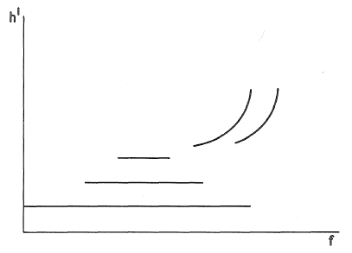

Figure 4. 23: Es type f, flat

Use only when a thick E layer is usually observable at the time of the ionogram. Otherwise use l.

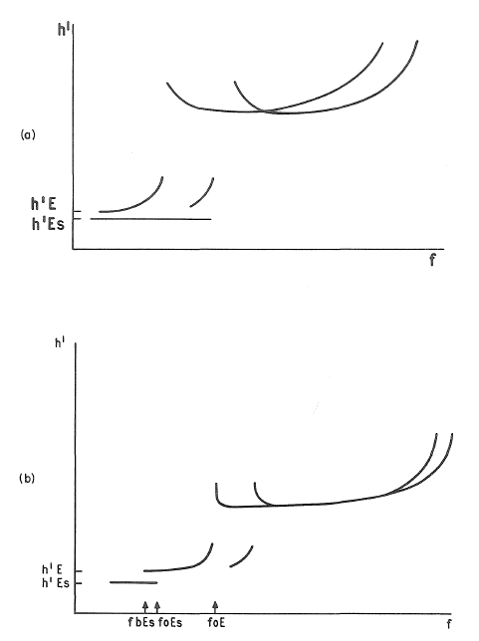

Figure 4. 24: (a) (b) Es type l low

Note a pattern similar to Fig. 4.23 with hʹEs less than the normal value of hʹE for the hour should also be classified as type l.

**Figure 4. 25 (a): Es type C, cusp**

Figure 4. 25 (b): Es type c, cusp

foE blanketed by c type Es.

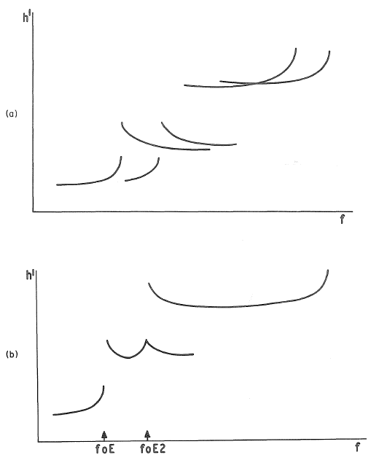

Figure 4. 26: Es type h, high

(a) The Es trace lies slightly above the E trace. The traces would not extrapolate to a common point except at a great height.

(b) A cusp like pattern from an intermediate stratification is also high - it is clearly above the normal E layer.

Figure 4. 27: Es type q, equatorial

A weak scattered trace extends to very high frequencies and does not blanket. Note Es type l can be superposed in the low frequency end of this trace and is then blanketing.

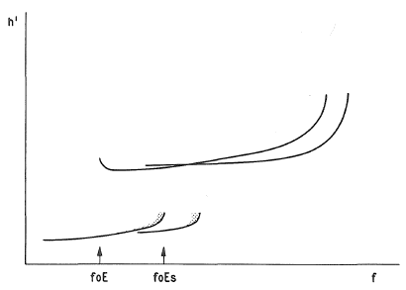

Figure 4. 28:Es type r, retardation

The trace is normally blanketing over part of its length. In this figure fbEs = foE, but the F trace can also show no retardation at fminF, see Fig. 4.2(a),(b)

Figure 4. 29: Es type a, auroral

A wide range of diffuse spread traces are classified as Es type a. Some common patterns are shown above. The F traces are usually, but not always, spread

Figure 4. 30: Es types, slant

Es types can arise from any type of Es trace or from foE or fxE. It is most commonly seen with types f, l , a, and occasionally q, r.

Incidence varies with station location. In the upper dia9ram, the slant Es is denoted by the dotted line and arises from an Es type l .

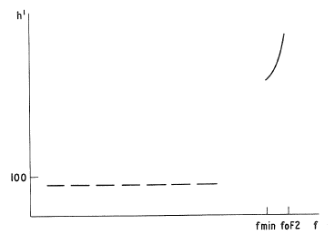

Figure 4. 31: Es types. Partial reflection from absorbing layer

A weak trace normally seen below 95 km and extending between 1 and 3 MHz, sometimes higher in frequency. All other traces show high absorption or are missing because of it (B condition).

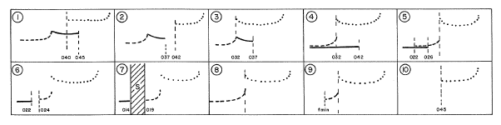

Figure 4. 32: Rules for interpreting foEs and fbEs in daytime.

Note: (a) Diagrams show only the ordinary trace

(b) For median determination, all values described by G or replaced by G are changed to (foE}EG.

(c) If gap exceeds limit for use of U, use DY or replacement letter Y according to accuracy rules.

|  |  |  |
| --- | --- | --- |
| No. | foEs | fbEs |
| 1 | 045 | 040 |
| 2 | 037 | 037UY |
| 3 | 037 | 032EG |
| 4 | 042 | 032EG |
| 5 | 026-G | 022-G |
| 6 | 022-G | 022-G |
| 7 | 014DG | 014DG |
| 8 | G | G |
| 9 | G | G |
| 10 | 045EB | 045EB |

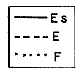

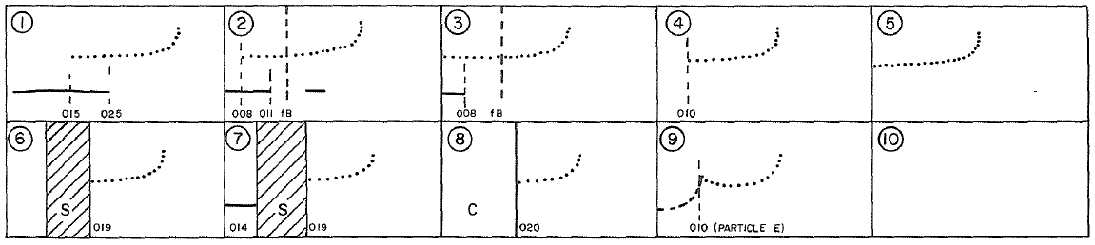

Figure 4. 33: Rules for interpreting foEs and fbEs at night.

Note: (a) Diagrams show only the ordinary F trace

(b) For particle E, foEs = fbEs = = (foE) – k

(c) No.10 correct provided sequence shoes foF2 above the minimum frequency of the ionosonde (in this case 007).

(d) fB = 1.2 MHz.



|  |  |  |
| --- | --- | --- |
| No. | foEs | fbEs |
| 1 | 019JA | 015 |
| 2 | 011 | 008 |
| 3 | 008 | 007EE |
| 4 | 010EB | 010EB |
| 5 | 007EE | 007EE |
| 6 | 019ES | 019ES |
| 7 | 014DS | 014DS |
| 8 | 020EC | 020EC |
| 9 | 010-K | 010-K |
| 10 | B | B |

* 1. Notes on distinguishing between Es types: The following notes are intended to help distinguish the correct type where pairs of types (e.g., f, a) may be confused. When in doubt the final decision is always to be based on the International Rules, section 4.83. Common but not essential features are stressed where these aid the identification.

f,a: Except when high absorption is present or foEs is below fB, flat Es type f usually shows multiple traces and is blanketing over at least part of the frequency range. In contrast Es type a seldom shows multiple traces. A little spread may be seen above Es-f on the first order when absorption is low whereas Es-a will show great spread for the same conditions.

When high absorption is present it can be difficult to distinguish between types a and f. A high gain ionogram can be used to help in this case. For Es-a there will be a significant increase in spread with gain, for Es-f little or no change. If spread is seen under high absorption conditions (fmin high), this by itself indicates type a rather than f, since the weak scatter often seen with type funder low absorption conditions is quickly removed by a small increase in absorption.

r,a: r traces usually show blanketing over part of the range and show a curved upper limit closely similar in shape to the retarded part of the normal E curve, with greatest heights near foEs. In contrast, Es-a traces usually cover a greater range of heights and often show maximum spread at a frequency well below foEs. Quite often the F trace shows retardation at a frequency appreciably lower than foEs suggesting the presence of particle E, and the r trace is blanketing to near this frequency.

l ,d: A weak l trace can sometimes resemble a high d trace, but is only seen when the absorption is low as denoted by a low value of fmin and multiple reflections from higher layers. The d type would be associated with high absorption. Frequently a weak l trace is seen only very near to foE, whereas the d trace usually extends to the lowest recorded frequencies. Very dense type l Es can occur at low heights, but then usually shows multiple traces. Type d never shows multiple traces.

q, l: When both are weak traces, q extends over a wide frequency range, l over a narrow, e.g., q might extend over 1-20 MHz, l over 1 to 3 MHz. When l extends over a wider frequency range it is blanketing over at least part of the range.

Where q is very common, combined q, l traces (l slightly higher than q) can be seen occasionally and distinguished by the blanketing effect of l at low frequencies, and the· normal value of foEs is associated with the q. Classify as q1, l 1. q is extremely rare except within about ±15° from the magnetic equator.

h,c: When absorption is high near foE, letter symbol R, compare relative heights of h'E, h'Es with similar values for clear cases of h,c. h'Es for h usually lies at least 10 km above h'E.

l ,z: At high latitudes, the z-mode reflection from Eis often lower than the o mode and can look similar to a low Es trace. Similar features separated by about fB/2 suggest Ez-mode rather than l. The z-mode trace usually blankets the lower part of the E trace, the blanketing frequency varying very slowly with time. Low type Es traces do not always blanket when foEs is less than foE, and their blanketing frequency usually varies rapid­ ly with time.

* 1. Provisional f plot indication of fxEs
  2. A number of stations are experimenting with the addition of the top frequency of Es (ftEs) to the f plot. To encourage conformity the following conventions are recommended:

1. The standard f plot rule that the f plot shows what was actually observed should be strictly obeyed.
2. An open triangle Δ is recommended when ftEs is equal to fxEs.
3. A closed triangle ▲is recommended:
4. if the value is doubtful
5. if the interpretation, fxEs, is doubtful
6. if the observed value of ftEs is foEs.
7. Limit values are indicated by adding the appropriate descriptive letter above the solid triangle if the true value is greater than that given, below if less.
   1. The additional information appears valuable provided it is restricted to the Es trace used to give foEs.

Note: When no Es traces are present during the daytime, the symbol for foE takes precedence over the symbol for Es i.e., use an open or closed circle, not a triangle, in these cases. The plotting of ftEs or fxEs on f plots is purely voluntary and is not at present recommended internationally.

* 1. Examples of scaling low-latitude Es (new heading)
  2. Sdasd
  3. Asdasda
  4. Examples of scaling mid-latitude Es (new heading)
  5. Sdasd
  6. Asdasda
  7. Examples of scaling high-latitude Es (new heading)
  8. Sdasd
  9. Asdasda
  10. References (new heading)
  11. We can add citations to papers that deal with the E2 layer here. BUT… they be useful for interpreting ionograms, this is not be a history lesson, a survey of everything we know, etc.
  12. Abc…

Annex 1: Holding space for Annex

* 1. The Communications Regulation Acts 2002-2011 (the “2002 Act”), the Common Regulatory Framework (including the Framework and Authorisation Directives as transposed into Irish law by the corresponding Framework and Authorisation Regulations), and the Wireless Telegraphy Acts set out, amongst other things, powers, functions, duties and objectives of ComReg that are relevant to this response to consultation and draft decision.

A1.1 Primary Objectives and …..

* 1. ComReg’s primary objectives in carrying out its statutory functions in the context of electronic communications are to:

1. For hours when foE, h'E are not usually recorded the entry should be left blank unless particle E is seen to be present. h'E and h'Es entries must be made when numerical values of foE and foEs are available. These may be numerical or replacement letters.